**Progress Report #2**

May 3, 2018

9352A 4:00 - 5:00 TF

Members:

FERRER, Lorelie Mae

LICUDO, Mary Ann

LOPEZ, Kimberly

MOLINA, Melody

SISON, Jhen Rose

**The group accomplishments for this week are the following:**

* Updated the outline in PHP

Member:

Melody Molina

* Finish the questions for quiz in PHP topic (Part1)

Member:

Melody Molina

* Created the database, coursenote.sql

Member:

Kimberly Lopez

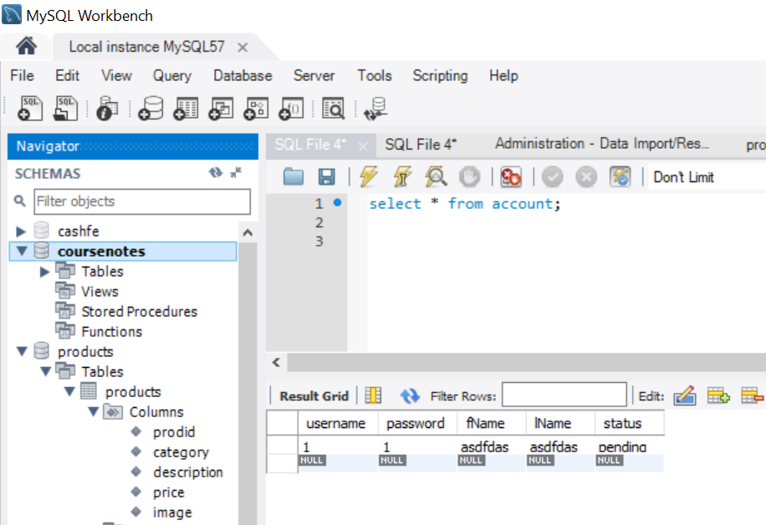

* Finished the signup module using PHP

Member:

Kimberly Lopez

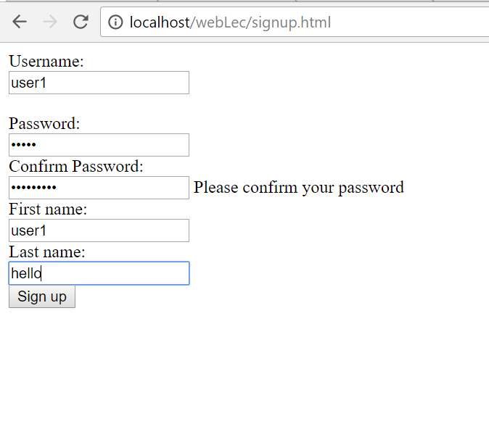

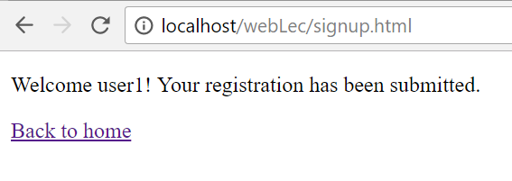

*Successful Registration*

* Finished the login and logout module using PHP

Member:

Mary Ann Licudo

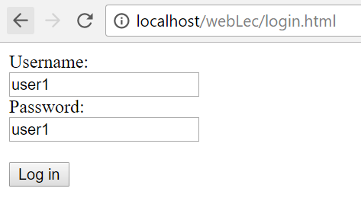

*Login*

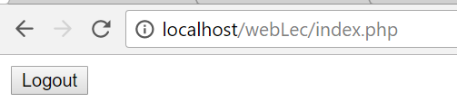

*Expected landing page*

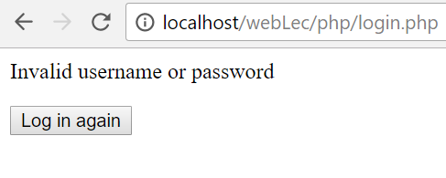

*Invalid login*

* Created the website icon for the topics

Member:

Jhen Rose Sison



* Started making the website Mobile – friendly or responsive

Member:

Lorelie Mae Ferrer

**Commit Logs:**

commit fce04ca975b35059b69b44a40155b3d1fe04e067

Author: Kimberly Lopez-2161055 <2161055@slu.edu.ph>

Date: Thu May 3 08:06:26 2018 +0800

merged the signup module and the log in module. Fixed minor issues in the session handling

commit e37ec638822050284c3ebc7dd7463d785b8cb57c

Author: Lmpf <2165944@slu.edu.ph>

Date: Thu May 3 05:46:15 2018 +0800

some changes on the index and topics page

commit 69cbadbd49d20261b4c2a77aaad7136ee57e08c0

Merge: 6502d95 344de7f

Author: Lmpf <2165944@slu.edu.ph>

Date: Thu May 3 04:00:08 2018 +0800

Merge branch 'master' of https://github.com/2164179mary/WEBTECHLEC

commit 6502d9596e999605c005892fa3e9de95478300b4

Author: Lmpf <2165944@slu.edu.ph>

Date: Thu May 3 03:58:00 2018 +0800

responsive menu (still under construction)

commit 344de7fcdd8362fb74d0a662e383ecb13e135cbc

Author: 2164194 <34298969+2164194@users.noreply.github.com>

Date: Thu May 3 02:13:44 2018 +0800

some php quiz.

commit 6774b600876647f8ea99e15a63ee9fd2eb9f95ea

Author: Jhen Rose <kimoais@gmail.com>

Date: Thu May 3 00:55:23 2018 +0800

RAW BANNER IMAGES

Added the raw images that can be use as banner for the website. The following images Banner 1.jpg to Banner 8.jpg, have the licensed to be use for personal or commercial purposes.

commit f2539178ea552d2c48bf90a1de3553f20dde97ba

Author: Mary Ann Licudo <34298410+2164179mary@users.noreply.github.com>

Date: Thu May 3 00:19:57 2018 +0800

Delete signup.html

commit 534f377cb7aaa374c89c64ffccfb2fd8ea77150d

Author: Mary Ann Licudo <34298410+2164179mary@users.noreply.github.com>

Date: Thu May 3 00:19:39 2018 +0800

Delete index.php

commit c8c3f9daca913c735d0d9c34f72b67ee86e72a9f

Author: Mary Ann Licudo <34298410+2164179mary@users.noreply.github.com>

Date: Thu May 3 00:19:25 2018 +0800

Delete index.html

commit 8d5d96c2f5f7e605d3ac461b0f6901841a806788

Author: Mary Ann Licudo <34298410+2164179mary@users.noreply.github.com>

Date: Thu May 3 00:19:08 2018 +0800

Delete admin.html

commit 3cbcf0ad876245e496d4bdde473cb0747e0bc35b

Author: Mary Ann Licudo <34298410+2164179mary@users.noreply.github.com>

Date: Thu May 3 00:17:05 2018 +0800

change landing page to index.html

commit 168c9ba445a82f9a0b5bacaddcd188242414428f

Author: Mary Ann Licudo <34298410+2164179mary@users.noreply.github.com>

Date: Thu May 3 00:14:00 2018 +0800

landing page changed to index.html

commit 2e5558b292f278fb4919046eab58792c79265005

Author: 2164194 <34298969+2164194@users.noreply.github.com>

Date: Wed May 2 23:06:50 2018 +0800

updated PHP notes

commit a767a779136d6a5e3ba55f53a8c35f6d9467eea7

Author: Mary Ann Licudo <34298410+2164179mary@users.noreply.github.com>

Date: Wed May 2 23:04:46 2018 +0800

included logout

Note: Same note as the previous version.

Note: Session not yet working

commit 757b62ab99c048183cce36422599d802b2bd9965

Author: Mary Ann Licudo <34298410+2164179mary@users.noreply.github.com>

Date: Wed May 2 22:21:54 2018 +0800

fixed username and password

Note: Arrange notification when username or password is incorrect. Output with the same page na lang

commit 71c9e9da653158a2b4eb3d808b308440ad0573a8

Merge: f322891 01ce361

Author: Jhen Rose <kimoais@gmail.com>

Date: Wed May 2 22:18:41 2018 +0800

Merge branch 'master' of https://github.com/2164179mary/WEBTECHLEC

commit f322891eec7c4e04018973c3d0b56cd84a7ad458

Author: Jhen Rose <kimoais@gmail.com>

Date: Wed May 2 22:18:35 2018 +0800

Edited Icon

Added the edited icon for PHP and SERVLET named ( "ICON_PHP.png" and "ICON_SERVLET" )

commit 01ce361894c933c8569b191c9b3df1478e1609a2

Author: Kimberly Lopez-2161055 <2161055@slu.edu.ph>

Date: Wed May 2 21:32:39 2018 +0800

added password validation for the signup module

commit 6cf15563be2a1dc53d728403784528028355b16d

Author: Mary Ann Licudo <34298410+2164179mary@users.noreply.github.com>

Date: Wed May 2 20:49:11 2018 +0800

log in, no username and password validation yet

commit dce8ac89a4c99e7a98ed426c6598b4a4f8f4c869

Author: Kimberly Lopez-2161055 <2161055@slu.edu.ph>

Date: Wed May 2 20:10:53 2018 +0800

SQL file and the signup module

**Things to be accomplished:**

* The group is still encountering an error regarding session handling using PHP. It is our goal to fix the said problem within this week.
* Accept/Deny in user registration module using PHP
* Summary of Course Topics
  + Java Web Servlets and Java Server Pages
* Convert the course topics to html format.
* Website
  + Pictures to be used for every topic
  + Dynamic content
  + CSS for the login and signup module
  + Banner typography